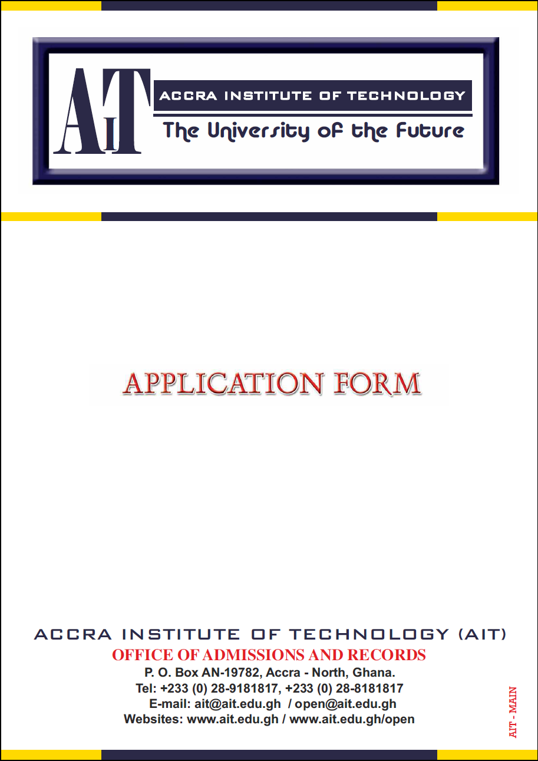

Dear Prospective AIT Student:

On behalf of Professor Francis Allotey, Chairman of the AIT Board of Trustees, and on behalf of the members of the Board of Trustees, the Faculty and Staff of AIT, I want to take this opportunity to express our appreciation to you for the interest you have shown in AIT.

We are delighted that you are applying to pursue your university education with us. You will see from the questions we ask that we are interested in who you are, and in your academic and other accomplishments. Please do take your time to study the questions asked and compose your responses carefully. The best applications come from students who have spent time on their applications, editing them and refining their key responses. Pleaseendeavour to give the application form your best attention

Let me assure you that we on our part will also read your completed application form thoughtfully, deliberately, and fairly. In the event that you make it to AIT, we will do all we can to provide you with a quality education utilizing our technological and learning resources to deliver your chosen program smartly and innovatively. We are committed to educating and training of tomorrow’s global leaders in all disciplines and fields. Our highest obligation as a university is to prepare our students who will live most of their lives in the 21st Century --- a century that will no doubt provide our graduates with significant new challenges and opportunities.

At AIT, we believe that we are preparing our students for the work-place, the economy, and the society of the future. The future is technology, and AIT is the University of the Future. – We provide technology-focused quality university education and training, specially trademarked and customized for the future.

We wish you well,and weeagerly look forward to having you at AIT.

Please let us know if we can be of further help to you.

God Bless You!

Best regards:

Professor Clement K. Dzidonu
AIT President

APPLICATION FOR ADMISSION FORM [UNDERGRADUATE AND POSTGRADUATE PROGRAMS]

PLEASE READ THE FOLLOWING INSTRUCTIONS CAREFULLY

To be considered for admission, you must submit:

1. A COMPLETED APPLICATION FORM

Please Complete the Application in BLOCK CAPITALS. Complete ALL sections of the application form. Illegible or incomplete forms may not be processed.

Visit the AIT website (www.ait.edu.gh) and read the relevant web pages or consult the AIT Handbook/Brochure for the details (including admission requirements) of the program you wish to pursue.

2. SUBMIT THREE (3) PASSPORT-SIZE PHOTOGRAPHS. The picture must be recently taken and it should be on a white background.

3. OFFICIAL TRANSCRIPTS AND CERTIFICATES

(a) A copy of your complete academic record indicating the subjects studied, grades achieved, and diploma(s)/degree(s) granted must be sent directly to AIT from each of the institutions attended and must bear the official seal/stamp of that institution/examination body.

(b) Unofficial statements of transcripts/grades/results may be submitted as interim working documents; however, an official final transcripts/grades/results must follow them.

(c) If the certificates which you are submitting are not in English, you will be required to provide notarized English translations together with copies of the original certificates.

(d) AIT transcripts need not be submitted.

Direct all inquiries and documents to:

DIRECTOR OF ADMISSIONS AND RECORDS
AIT ADMISSIONS OFFICE
ACCRA INSTITUTE OF TECHNOLOGY
P.O BOX AN-19782, ACCRA-NORTH, GHANA

Tel. 233-28-9181817, 233-21-786053, 233-28-8181817

E-mail enquiries may be forwarded to: admissions@ait.edu.ghWebsite: www.ait.edu.ghor www.aitedu.us

Note: Students must note that neither this application nor supplementary acknowledgement material constitutes an offer of admission to study at AIT. Successful candidates will receive admission letters clearly outlining the program of admission and other pertinent details. Students are also advised that supporting material cannot be returned.
.

A. Personal Details

First Name: Middle Name: Surname:

Sex: Male Female Date of Birth Nationality:
Address:

Tel.: (Landline) (Mobile) E-mail:

B. Parent/Guardian Details

Guardian/Father

First Name: Middle Name: Surname:

Address:

Tel.:(Landline) (Mobile) E-mail:

Guardian/Mother

First Name: Middle Name: Surname:

Address:

Tel.:(Landline) (Mobile) E-mail:

In Case of Emergency AIT Should Contact:

Name: Relationship:

Address:

Tel.:(Landline) (Mobile) E-mail:

C. Educational Background

C.1: Which of the following best describe the highest level of your educational attainment?

Senior Secondary School/High School Technical/Vocational School

Post-Secondary Education/Training (e.g. Certificate, Diploma Level Courses). Please specify which course/level:

Course: Level:

University/Polytechnic/College [State Diploma/Degree Obtained]:

C.2: Sec/High School/University/Polytechnic/College Attended

Name of Institution Town/City Country From To Qualification
YY YY (WASSCE/HND/BSc/MSc etc)

C.3: Senior Secondary School/High School/Technical/Vocational School Grades

For those applying for Undergraduate certificate/diploma/degree programs and have completed Senior Secondary School/High School/Technical/Vocational School: please list the courses taken and the grades obtained at the End-of-School Certificate/Diploma examinations (e.g.Senior Secondary/High School Certificate Examination (SS/HSCE) or West African Senior Secondary School Certificate (WASSCE), ‘O’ Level Certificate, ‘A’ Level Certificate Examinations OR Other Equivalents)

Subject Grade Subject Grade

C.4: Additional Training(Certificate/Diploma Courses, Professional Training/Courses/Programs Industrial Training/Work)

Subject/Subject/Program Institution/Exam Body Completion Date
MM YY

D. Employment History/Work Experience

Employer & Location Nature of Work PT/FT From To
(Town/City, Country) MM/YY MM/YY

E. Program Selection

Please Select (Tick) which Program You want to Apply For. You are Allowed Three (3) Choices – Ranked in order of Preference.

For each Program you Select, Please indicate in the far right column [1 for 1st ; 2 for 2nd ; 3 for 3rd Choice]

Note: Please check the minimum entry/admission requirements for each of the programs before applying for it.

Undergraduate and Postgraduate Programs
Select (Tick) Program | Rank Your Choice  [1,2,3]
AITBusinessSchool (ABS)
Certificate of Technology (CTech) in Business Administration & Info Tech (IT)
Certificate of Technology (CTech) in Accounting and Finance
Certificate of Technology (CTech) in Marketing & Information Technology (IT)
Certificate of Technology (CTech) in Management Information System (MIS)
Diploma of Technology (DTech) in Business Administration and IT
Diploma of Technology (DTech) in Accounting and Finance
Diploma of Technology (DTech) in Marketing & Information Tech (IT)
Diploma of Technology (DTech) in Management Information System (MIS)
Bachelor of Science (BSc) in Business Administration (Accounting & Finance)
Bachelor of Science (BSc) in Business Administration (E-Commerce)
Bachelor of Science (BSc) in Business Administration (Entrepreneurship & Information Technology)
Bachelor of Science (BSc) in Business Administration (Marketing & Information Technology)
Bachelor of Science (BSc) in Business Administration (Banking, Finance & Information Technology)
Bachelor of Science (BSc) in Business Administration (Human Resource Management & Information Technology)
Bachelor of Accounting
Bachelor of Tourism Management
Bachelor of Human Resource Management
Master of Business Administration (MBA)
Master of Management
MSc in Business Administration (Research Only)
Master of Project Management
PhD (Business Administration)
Industrial-Based (DTech) Programs
DTech in Entrepreneurship and Information Technology
DTech in Marketing and Information Technology
DTech in Business Accounting Technology
DTech in Human Resource Management & Information Technology
DTech in Management Science and Information Systems
Advanced School of Systems and Data Studies (ASSDAS)
Certificate of Technology (CTech) in Information Technology (IT)
Certificate of Technology (CTech) in Computer Science
Diploma of Technology (DTech) in Information Technology (IT)
Diploma of Technology (DTech) in Computer Science
Bachelor of Science (BSc) in Information Tech (IT) (Network Systems)
Bachelor of Science (BSc) in Information Tech (IT) (Web Dev. & Engineering)
Bachelor of Science (BSc) in Information Tech (IT) (Multimedia Systems)
Bachelor of Science (BSc) in Information Tech (IT) (E-Commerce)
Bachelor of Science (BSc) in Information Tech (IT) (Software Development)
Bachelor of Science (BSc) in Computer Science
Bachelor of Information Technology
Bachelor of Information Technology and Software Eng.
Bachelor of Information Technology with Network Computing
Bachelor of Information Technology and Management
Bachelor of Information Technology with E-Commerce
Bachelor of Information Technology with Accounting
Bachelor of Computer Science
Bachelor of Multimedia Communications
Master of Information Technology
Master of Software Engineering
Master of Multimedia Communications
PhD (Information Technology)
Industrial-Based (DTech) Programs
DTech in Computer Networks Technology
DTech in Software Applications Development Technology
DTech in Computer Hardware Systems Technology
DTech in Web Development Technology
School of Advanced Technologies, Engineering and Science (SATES)
Certificate of Technology (CTech) in Computer Engineering
Certificate of Technology (CTech) in Civil Engineering
Certificate of Technology (CTech) in Electrical and Electronic Engineering
Certificate of Technology (CTech) in Electromechanical Engineering
Certificate of Technology (CTech) in Industrial Engineering
Certificate of Technology (CTech) in Telecommunications Engineering
Certificate of Technology (CTech) in Software Engineering
Diploma of Technology (DTech) in Computer Engineering
Diploma of Technology (DTech) in Civil Engineering
Diploma of Technology (DTech) in Electrical and Electronic Engineering
Diploma of Technology (DTech) in Electromechanical Engineering
Diploma of Technology (DTech) in Industrial Engineering
Diploma of Technology (DTech) in Telecommunications Engineering
Diploma of Technology (DTech) in Software Engineering
Bachelor of Engineering (BEng) in Computer Engineering
Bachelor of Engineering (BEng) in Civil Engineering
Bachelor of Engineering (BEng) in Electrical and Electronic Engineering
Bachelor of Engineering (BEng) in Electromechanical Engineering
Bachelor of Engineering (BEng) in Industrial Engineering
Bachelor of Engineering (BEng) in Telecommunications Engineering
Bachelor of Engineering (BEng) in Software Engineering
UK Engineering Council Certificate
UK Engineering Council Graduate Diploma
UK Engineering Council Post Graduate Diploma
Advanced Diploma (C&G) in Oil and Gas Operations (Engineering)
Bachelor of Occupational Health & Safety Management
Bachelor of Technology Management
Bachelor of Manufacturing Management
Master of Engineering [MEng] (Research Only)
Master of Environmental Science
Master of Occupational Safety & Risk Management
Master of Project Management
PhD (Engineering)
Industrial-Based (DTech) Programs
DTech in Telecom Engineering Technology
DTech in Renewable Energy Engineering Technology
DTech in Electrical & Electronic Engineering Technology
DTech in Electrical Wiring Technology
DTech in Industrial Engineering Technology
DTech in Civil Engineering Technology
DTech in Pharmaceutical Manufacturing Tech
DTech in Computer Engineering Technology
DTech in Mobile & Wireless Engineering Technology
DTech in Occupational Health & Safety Management
DTech in Oil and Gas Engineering Tech & Management
DTech in Software Engineering Technology
DTech in Web Engineering Technology
DTech in Manufacturing Technology Management
DTech in Computer-based Engineering Design & Modeling
DTech in Automobile Engineering Technology
DTech in Construction Management and Quantity Surveying Engineering Tech
DTech in E-Waste Management Engineering Technology
DTech in Quantity Surveying and Cost Engineering Technology
DTech in Surveying Engineering Technology
DTech in Modern Journalism and Technology
DTech in Broadcasting Engineering Technology
DTech in Industrial Welding Engineering Technology
DTech in Building Engineering Technology
School of Education and Instructional Technologies (SEIT)
Bachelor of Education [BEd] (Primary Education)
Bachelor of Education [BEd] (Education Administration)
Bachelor of Education [BEd] (Science)
Bachelor of Education [BEd] (Mathematics)
Master of Instructional Design and Technology
Master of Education [MEd]
PhD (Education)
Industrial-Based (DTech) Programs
DTech in Educational and Instructional Technologies

F. Program Delivery Mode/Session/Schedule Selection

F.1: Mode of Delivery

Please select (Tick) which of the following course/program delivery mode(s) is suitable for you:

Campus-Based (WillAttend face-to-face Classes/Lectures at one ofAIT's Physical Campuses)

Online:Over the Internet (Will access my courses and learning materials online over the Internet using theAIT
Lemass System.Will not attend regularly scheduled face-to-face classes other than attend scheduledTutorial
Sessions at any ofAITPhysical Campuses)

Online: NotOvertheInternet(Willreceivemycoursesandlearningmaterialson
CDs/Pendrives/Printedformat and/or access my courses over an Intranet at anAITE-Learning Center.Will
not attend regularlyscheduled face-to-face classes other than attend scheduledTutorial Sessions at any ofAIT
Physical Campuses)

F.2: Online Program Option Selection

For those opting for online program delivery mode, Please select which of the following schedules is most appropriate for you:

Online – Instructor-Led (Students selecting this lecturer-assisted online learning option will have full access to
all the relevant learning materials and resources on our learning management system – LeMASS and will in addition have access to and interact with AIT lecturers online. They will also attend scheduled campus-based tutorial sessions with theinvolvement of these lecturers).

Online – Independent-Study (Students selecting this option will have full access to all the relevant learning
materials and resources on our learning management system – LeMASS and will in addition attend scheduled
campus-based tutorial sessions with the involvement of AIT lecturers).

F.3: Campus-Based Program Session/Schedule Selection

For those opting for campus-based program delivery mode, Please select which of the following schedules is most appropriate for you:

Day Session: 8.00 am to 5.00 pm

Evening Session: 6.00 pm – 9.00 pm

Weekend Session: Friday [6.00 pm -9.00 pm], Saturday [8.00 am – 6.00 pm] and Sunday [8.00 am – 6.00 pm]

G. Campus/Student Activities

G.1: Indicate your interests in campus activities: (check all that apply)

Bands |  | Dance | Debate
Campus Service |  | Cultural Troupe | Departmental Clubs
Event Planning |  | University Choir | Instrumental Music
Intercollegiate Athletics |  | Sports | Leadership
Publications |  | Religious Organizations | Study Abroad
Student Government |  | Radio-TV | Drama/Theatre
Vocal Music |  | Teaching/Tutorials | Traditional Dancing
Keep Fit Club |  | Walking/Jogging | Business Club
Fishing |  | Camping | Site Seeing/Excursions
Public Speaking |  | Voluntary Service | Community Service
Others (Specify)

H. Work-Study Scholarship Programs

H.1:If you want to be considered for AIT’s Work Study Scholarship Program, indicate (tick) below the work area(s) of interest to you:

Computer Lab. Assistant | Engineering Lab Assistant
Campus Maintenance - Cleaning | Campus Maintenance - Handyman
Campus Maintenance - Gardening | University Catering Services
Teaching Assistant | University Cyber Café Assistant
Secretarial Work | Software Development Support
University Radio Station | Teaching/Lessons/Tutorial Support
University Band | University Cultural Troupe
StudentFirst Services | Administrative Support

H.2: List/Describe below relevant Skills, Work Experience or Expertise that best qualifies you for your choice of work-study area(s)

I. Further Information

I.1: Use the space below to provide us with any further information you want us to take into account in evaluating your application for admission

I.2: In few words please tell us your reasons for choosing to come and study at AIT

J. Referees
Provide Name and Address of Two Referees

Name in Full:  Address:  Tel:  Email: | Name in Full:  Address:  Tel:  Email:

K. How to Submit/Deliver Your Completed Application for Admission Form

- This is a fillable form, meant to be completed on the computer in an electronic format. Please send the completed electronic form to us as an e-mail attachment to: admissions@ait.edu.gh

- In case you instead printed and completed the hard (printed) copy of the form, you have 3 choices: (i) You can scan the completed form and send it to us as an e-mail attachment to: admissions@ait.edu.gh or (ii) Post/Courier the completed Application Form with photocopies of your certificates, transcripts and 3 passport-size photographs to: AIT, Admissions Office, P.O Box AN-19782, Accra-North, GHANA or (iii) Come to our Cantonments Campus and deliver the completed form in person. We are opposite Aquinas Sec. Sch/Morning Star Sch, Behind the Government Secretarial School. You may want to call us on 028-8181817, 028-9181817.

Note: Completed Application Forms submitted to AIT either online or in person will be processed only after the payment of the non-refundable Application Processing Fees.

L. How to Pay Your (Non-Refundable) Application Processing Fees

Note: Application Processing Fees are not transferable, non-refundable and cannot be deferred.

The Application Processing Fees (APF) for Undergraduate Admission are:

CTech/DTech Programs
Ghanaian Students: GH¢60.00 Foreign Students: $60.00

Degree Programs
Ghanaian Students: GH¢60.00 Foreign Students: $60.00

Masters Programs
Ghanaian Students: GH¢120.00 Foreign Students: $120.00

PhD Programs
Ghanaian Students: GH¢150.00 Foreign Students: $150.00

Note: Foreign Students applying from within Ghana should use the current Forex Bureau buying rate for the US Dollar to calculate the Ghana Cedi equivalent of the Application Processing Fee. If in doubt, please call us on 028-8181817, 028-9181817for the current exchange rate.
Payment Instructions for Applicants in Ghana

For those who download the Application Form from our Website you will need to pay the Application Processing Fee. Please follow the instructions below:

- Go to any branch of Ghana Commercial Bank in the country and Pay-in Your Application Processing Fee into our Ghana Commercial Bank Account. The Bank Account Details are:

Name of Account: ACCRA INSTITUTE OF TECHNOLOGY
Bank Branch: GHANA COMMERCIAL BANK, CIRCLE BRANCH, ACCRA
ACCOUNT NUMBER: 127 113 000 3725

- Send (by Post or Registered Mail) the completed Application Form with a photocopy of the pay-in slip and photocopies of your certificates, transcripts and 3 passport-size photographs to us or Come to our Cantonments Campus and deliver the completed Application Form, the pay-in slip and other documents in person.
Payment Instructions for Applicants outside Ghana
You can select one of the following payment methods:

- Send us an International Money Order payable to the Accra Institute of Technology (AIT)
- Transfer the Application Processing Fees (APF) to us by Western Union Money Transfer
- In case you are having difficulty using options 1 or 2 above, Please Send an e-mail to us at apf@ait.edu.gh
or call us on 233-28-8181817 or 233-28-9181817 for advise on other payment possibilities.

M. Declaration

I confirm that the information given on this application form is correct and complete. I accept that the University has the right to cancel my application if it is found out that I have provided false or inaccurate information. I have read the instructions, in particular those regarding this section and I understand what they say. I agree to abide by the conditionsset out there, which I accept as a condition of this application.

Name: Date:

Please visit our websites (www.ait.edu.gh and www.ait.edu.gh/open) and learn more about AIT and our programs

FOR OFFICIAL USE ONLY

AFRN: APFC: Date:

TRPT: CHK ACT RJT CERT: CHK ACT RJT Date:

DN: R CT DT L1 L2 L3 E CH DF E-XAM

ITV

Date:
REGD: Date: Student ID Number:



